Heat Cheat Sheet

Ahead of the weekend and the hot weather, please find below a few reminders about keeping cool and staying safe in hot weather.
Keep Hydrated
Drink plenty of fluids to stay hydrated – the key is to drink regularly throughout the day (at least 6-8 mugs). There is cool water available at all the venues over the weekend, as well as Water Coolers at the Town Hall and Pump Rooms.
Don’t rely solely on thirst as a sign you need to drink. By the time you are thirsty you may already be dehydrated.
Hydration | NHS inform
Heat related Illness – know the signs
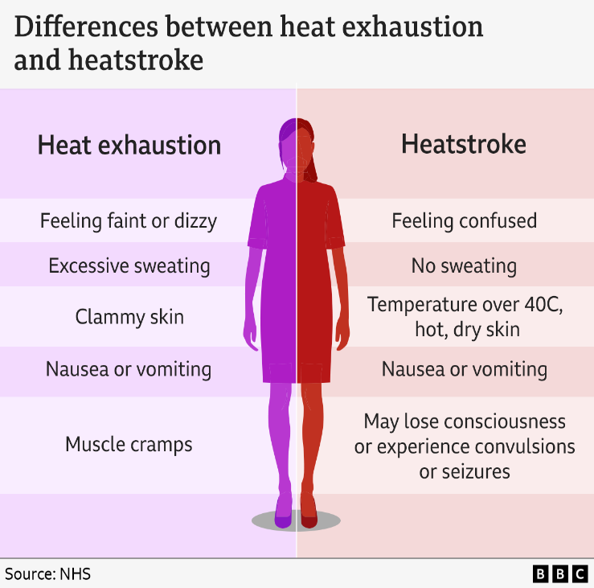
4 quick ways to feel better
- Move to a cool place
- Drink plenty of water
- Remove all unnecessary clothing like a jacket or socks.
- Cool your skin – spray or sponge them with cool water and fan yourself. Ask someone else to do this for you if that’s an option. Cold packs, wrapped in a cloth and put under the armpits or on the neck are good too.
You should start to cool down and feel better within 30 minutes.

If a person feels hot and dry, is not sweating even though they are too hot, has rapid or shortness of breath and is confusion or shows a lack of coordination, they could be suffering from heat stoke, which can be life threatening, please call 999 for medical assistance.
Heat exhaustion and heatstroke - NHS

